Infinitive Phrase Attribute

✅ What is Infinitive Phrase Attribute?
# Source: AI Source: Provided by: [Data Path: Persons Table -> ID Column: 1, Name_En Column: Motasem Essam] -> From: [Chatgpt (GPT‑5 Mini)] on [8/7/2025]
An Infinitive Phrase Attribute is an infinitive phrase (to + base verb) that functions as an attribute by modifying a noun, typically explaining purpose, function, or intended use of that noun. It acts similarly to an adjective.

🔹 Structure:
# Source: AI Source: Provided by: [Data Path: Persons Table -> ID Column: 1, Name_En Column: Motasem Essam] -> From: [Chatgpt (GPT‑5 Mini)] on [8/7/2025]
Infinitive Phrase = to + verb + (optional object/modifiers)
Placement: Usually comes after the noun it modifies.

🔹 Functions of Infinitive Phrase Attributes:
# Source: AI Source: Provided by: [Data Path: Persons Table -> ID Column: 1, Name_En Column: Motasem Essam] -> From: [Chatgpt (GPT‑5 Mini)] on [8/7/2025]
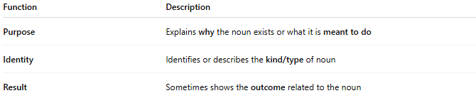
Function | Description
Purpose | Explains why the noun exists or what it is meant to do
Identity | Identifies or describes the kind/type of noun
Result | Sometimes shows the outcome related to the noun

🔹 Examples in Sentences:
# Source: AI Source: Provided by: [Data Path: Persons Table -> ID Column: 1, Name_En Column: Motasem Essam] -> From: [Chatgpt (GPT‑5 Mini)] on [8/7/2025]
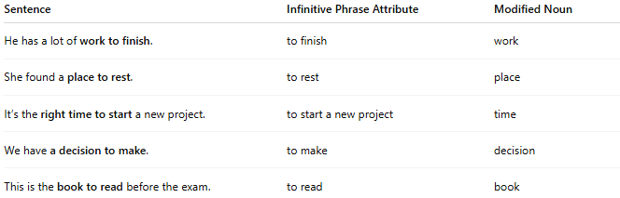
Sentence | Infinitive Phrase Attribute | Modified Noun
He has a lot of work to finish. | to finish | work
She found a place to rest. | to rest | place
It’s the right time to start a new project. | to start a new project | time
We have a decision to make. | to make | decision
This is the book to read before the exam. | to read | book

🔹 Quick Comparison:
# Source: AI Source: Provided by: [Data Path: Persons Table -> ID Column: 1, Name_En Column: Motasem Essam] -> From: [Chatgpt (GPT‑5 Mini)] on [8/7/2025]
Type | Acts Like | Position | Modifies
Infinitive Phrase Attribute | Adjective | Usually after noun | Noun

🔹 Common Nouns Often Modified by Infinitives:
# Source: AI Source: Provided by: [Data Path: Persons Table -> ID Column: 1, Name_En Column: Motasem Essam] -> From: [Chatgpt (GPT‑5 Mini)] on [8/7/2025]
- Time (time to go)
- Place (room to grow)
- Opportunity (chance to speak)
- Ability (skills to learn)
- Thing (something to do)

